Microservices Notes

Problem:

* Execute synchronized update for bank account. How to validate synchronized DB ?

Solution:

1. DB guarantee that by applying 2 phases commit and 2 phases lock protocol by locking updating DB record until executing 1 update then refresh data before executing second update.
2. For distributed system we can apply Event sourcing or Saga design pattern to communicate between microservices.

Problem:

* How to implement transactions that span services? 2PC is not an option.
* What is Saga Design Pattern and what is the benefits of applying it?
* have a credit limit. ensure a new order will not exceed the customer’s credit limit. Orders and Customers are in different databases owned by different services the application cannot simply use a local ACID transaction.

Solution:

* It enables an application to maintain data consistency across multiple services without using distributed transactions
* Each local transaction updates the database and publishes a message or event to trigger the next local transaction in the saga
* If a local transaction fails because it violates a business rule then the saga executes a series of compensating transactions that undo the changes that were made by the preceding local transactions.
* **Cryptograph based Saga** [no orchestrator in order service]

each local transaction publishes domain events that trigger local transactions in other services

* 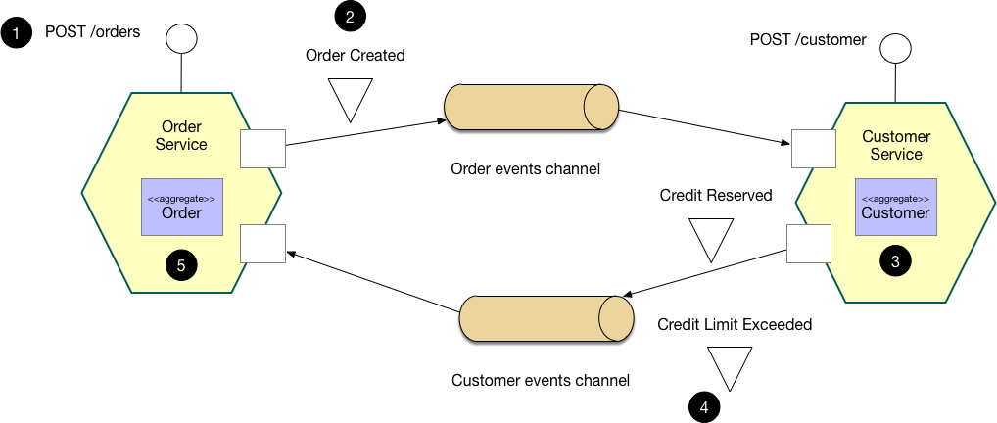

1. The Order Service receives the POST /orders request and creates an Order in a PENDING state
2. It then emits an Order Created event
3. The Customer Service’s event handler attempts to reserve credit
4. It then emits an event indicating the outcome
5. The OrderService’s event handler either approves or rejects the Order

* **Orchestration- based Saga** [orchestrator exist to decide and send to other services]

an orchestrator (object) tells the participants what local transactions to execute

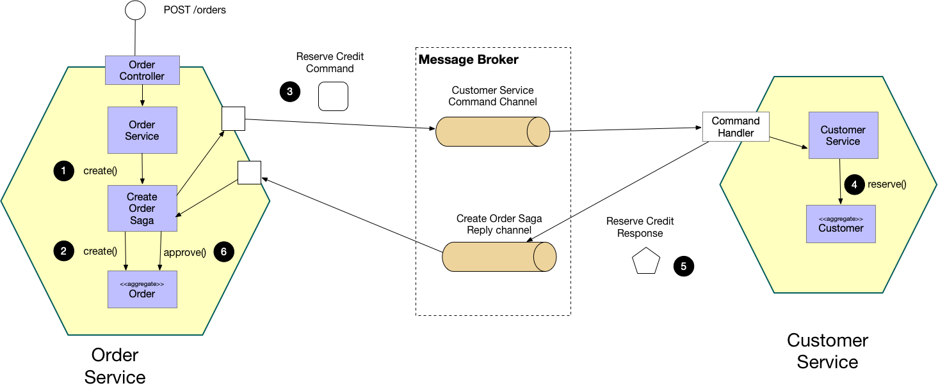

Related Patterns:

* The Database per Service pattern creates the need for this pattern
* The following patterns are ways to *atomically* update state *and* publish messages/events:
* [Event sourcing](https://microservices.io/patterns/data/event-sourcing.html)
* [Transactional Outbox](https://microservices.io/patterns/data/transactional-outbox.html)
* A choreography-based saga can publish events using Aggregates and Domain Events Design patterns.

Problem:

* How to implement queries in a microservice architecture?

Solution:

* Implement a query by defining an **API Composer,** which invoking the services that own the data and performs an in-memory join of the results.

Benefits:

* simple way to query data in a microservice architecture

Drawback:

* Some queries would result in inefficient, in-memory joins of large datasets
* Solution may be using CQRS for segregate reading data from writing.

Note:

* API Gateway apply API Composer Design Pattern [Single Entry Point to access services]

Related Patterns:

* The CQRS pattern is an alternative solution.

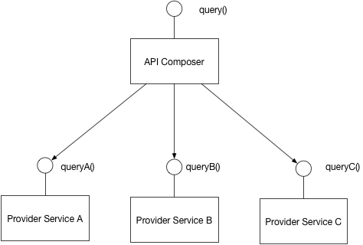

Problem:

* What is CQRS ?
* How to implement a query that retrieves data from multiple services in a microservice architecture?

Solution:

* Command Query Responsibility Segregation
* Define read-only Database replica to support queries only
* Keep replica data up to date using DDD aggregation [Domain event] subscription, [publish events when they created or updated].
* We can use Redis Caching Memory DB as well ☺

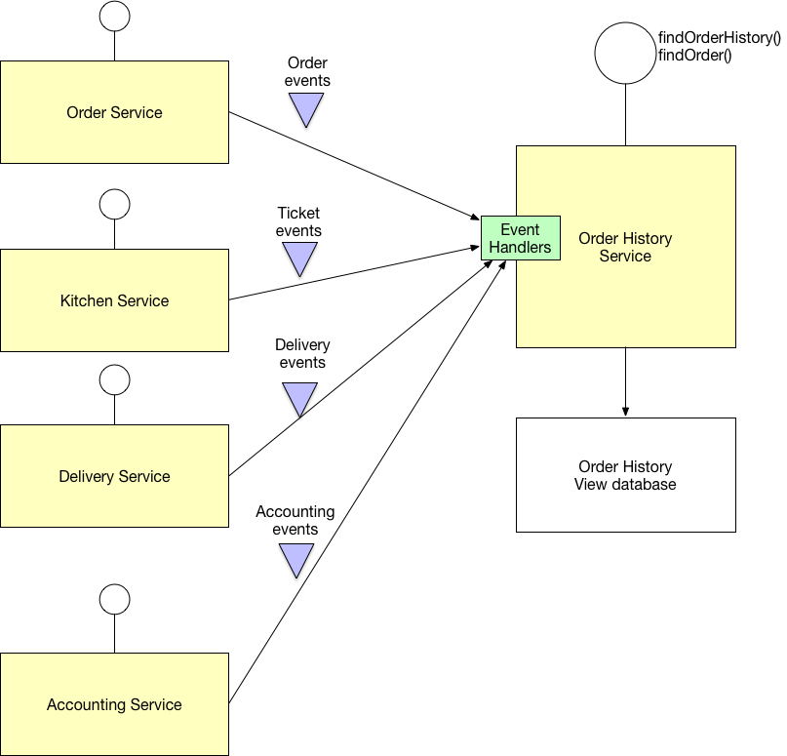

**Data integrity is the overall accuracy, completeness, and consistency of data**

Problem:

* What is two-phase commit (2PC) ?

Solution:

* standardized protocol that ensures atomicity, consistency, isolation and durability (ACID) of a transaction
* For distributed System [multiple Databases], It is an atomic commitment protocol
* The database must store a copy of the transaction’s updates before a failure occurs. 2PC ensures that each system accessed by a transaction durably stores its portion of the transaction’s updates before the transaction commits anywhere.

Problem:

* How does two-phase commit work?

Solution:

* special object, known as a coordinator, is required -> arranging activities and synchronizations between distributed servers.
* consists of two phases

Phase 1:

* every resource manager stores their updates in log storage (Every server that is required to commit writes its data records in a log)
* Initiating node requests for all participating nodes
* Waiting response (prepared, Read-only, Abort)
* Modifying data itself -> lock is then placed on the modified tables to prevent them from being read.
* Prepared nodes then wait for either a commit or rollback response from the global coordinator [in-doubt status]

Phase 2:

* tells all resource managers to commit or rollback all if any failure that all commits is stored in logs before committing.

Problem:

* Compare between 2PC vs Saga ?

Solution:

* same goal: to coordinate resources while overlaying operations form a coherent unit of work. But they are using different approaches.
* 2PC: allows programmer to execute transaction as one unit in distributed system by committing or rollback all. It is already used in Most of DB engines in local DBs and may be in distributed DBs as well. No need to program it.
* Saga: allow programmer to execute transaction as one unit in distributed System but allowing execute it in period of time [It is not required immediate exaction]

Problem:

What is Domain-Driven Design (DDD) ?

Solution:

* Service publish events when it updates its data
* Organize the business logic of a service as a collection of DDD [aggregates](https://microservices.io/patterns/data/aggregate.html) that emit domain events when they created or updated
* Service publishes these domain events so that they can be consumed by other services

Related Patterns:

* The Saga and CQRS patterns create the need for this pattern
* The Aggregate pattern (A graph of objects that can be treated as a unit.) is used to structure the business logic
* **Transactional outbox** pattern is used to publish events **as part of a database transaction**
* Event sourcing is sometimes used to publish domain events.

Problem:

* What is Transactional outbox ?
* How to reliably/atomically update the database and send messages/events?
* 2PC is not an option. Message broker may not support 2PC. If does, It is not good practicing to couple between message and transaction. Transaction may be executed and response message craches.

Solution:

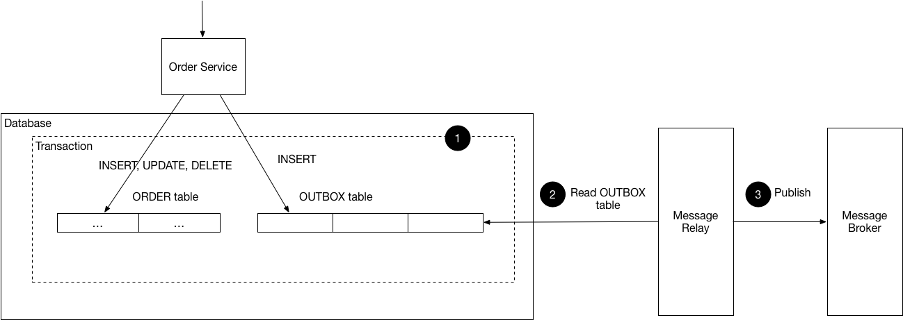

* service that uses a **relational** database inserts messages/events into an **outbox table, NoSQL** DB we can use **attribute** in record [Document or Item] being updated.
* Message Relay Process can publish the events inserted in DB to message broker.
* It is useful with **Saga** and **Domain Event** design patterns.
* **Event-Sourcing** design pattern is alternative solution for same target.

Drawback:

* Developer may forget publishing the message after updating DB.
* Message Relay may send the message more than one time. It might happen, after sending the message, system may be crashed before recording message is published.

[This point is not actually issue because it is resolved by default ☺]

message consumer must be idempotent, perhaps by tracking the IDs of the messages.

Actually any Message Consumers need to be idempotent(handling multiple calls for same message) because any most of message broker support deliver messages more than once.

Problem:

* What is Event Sourcing Design Pattern?

Solution:

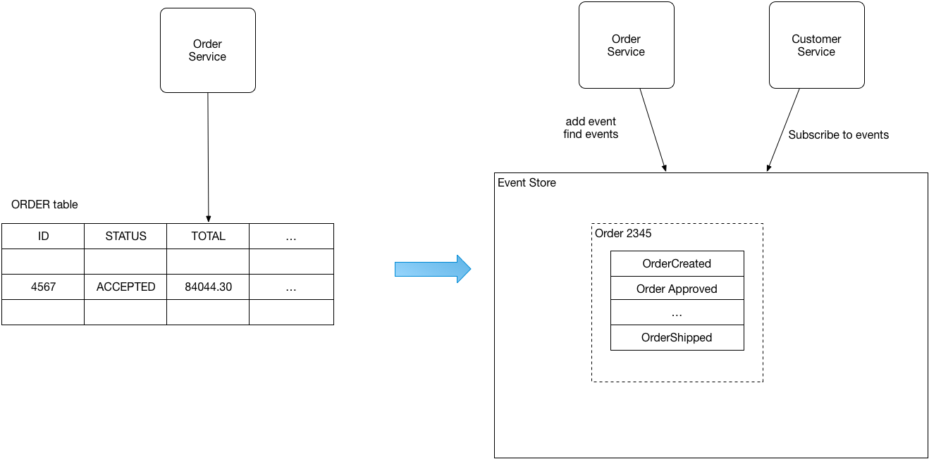

* Event sourcing persists the state of a business entity such an Order or a Customer as a sequence of state-changing events.
* Whenever the state of a business entity changes, a new event is appended to the list of events
* Since saving an event is a single operation, it is inherently atomic.
* The store has an API for adding and retrieving an entity’s events
* The event store also behaves like a message broker.
* It provides an API that enables services to subscribe to events
* When a service saves an event in the event store, it is delivered to all interested subscribers
* Customer, can have a large number of events, so an application can periodically save a snapshot of an entity’s current state
* Event sourcing implements the Audit logging pattern.
* The Saga and Domain event patterns create the need for this pattern.

Advantages:

* It resolves the problem of reliable publish events whenever changing the event’s state.
* It saves events instead of object so no object-relational mismatch problem.
* 100% reliable audit log of business entity changes.
* Possible to make queries to determine the state of business entities at any point of time.
* loosely coupled business entities that exchange events

Drawbacks:

* unfamiliar style of programming and so there is a learning curve
* event store is difficult to query so may use CQRS for queries ☺

Simplify Design Needs ☺

|  |  |  |
| --- | --- | --- |
| Maintain data consistency | Implement queries | Communicate using transactional messaging |
| **Saga** | **CQRS** | **Transactional Outbox**  or  **Event Sourcing** |

Problem:

* What’s the database architecture in a microservices application?

Solution:

* Loosely coupled DB. Each Service has full access for its own DB.
* - if you are using a relational database then the options are:
* Private-tables-per-service
* Schema-per-service
* Database-server-per-service
* Using a schema per service is preferred since it makes ownership clearer with less overhead.
* OR Database-server-per-service which is better (create barriers [grants and control access] that enforce this modularity) but more overhead.

Benefits:

* loosely coupled.
* Each service can use the type of database that is best suited to its needs.

Drawbacks:

* business transactions that span multiple services is not straightforward [Distributed transactions are best avoided because of the CAP theorem] -> **Solution:** Saga, Transactional Outbox
* queries that join data that is now in multiple databases is challenging -> **Solution:** CQRS or API Composition
* Complexity of managing multiple SQL and NoSQL databases

**KAFKA Message Broker**

Problem:

* How Kafka handles messages?

Solution:

* Kafka is high available
* In other words, Topic is meaning Queue
* Partition:
* to handle many consumers instance, one consumer (or one partition) handle one business unit [order] events [order -> created, updated, canceled]. It guarantees executions of events in same order as sent by assigning it to one consumer (tracked by).
* assign a special key [order-Id for example] to the message to be handled by same consumer.
* Another way to use special key by assigning surname starts from letter belongs to range A-M should go to the first partition and for clients whose surname starts from N-Z should go to the second partition.



* Configuring “enable.auto.commit=false”
* Will guarantee sending message once at least to consumer even if broker shutdown before sending this message [For example, Consumer gets a message but shut down before making all necessary operations against DB]
* But unfortunately consumer may receive message twice
* Kafka is using offset. Messages before this offset is sent. When auto.commit=false, it will not move this message before offset [meaning it is sent] until it receive knowledge message from consumer and this guarantee enough
* But In this case, If we are using partition and “Order_Payment” sent and “Order_Update” not sent for example and kafka shutdown. It will send “Order_Payment” again. So that we have an issue here need to be handled



* Making message handler is idempotent, meaning if calling it multiple times with the same payload has no additional effect.
* Solving duplicate messages will be handled from Consumer side
* It’s easy to implement to introduce a new table, for example, PROCESSED_MESSAGE where we would store all message ids which is already processed.
* Or in other words we can use Transactional outbox design pattern ☺

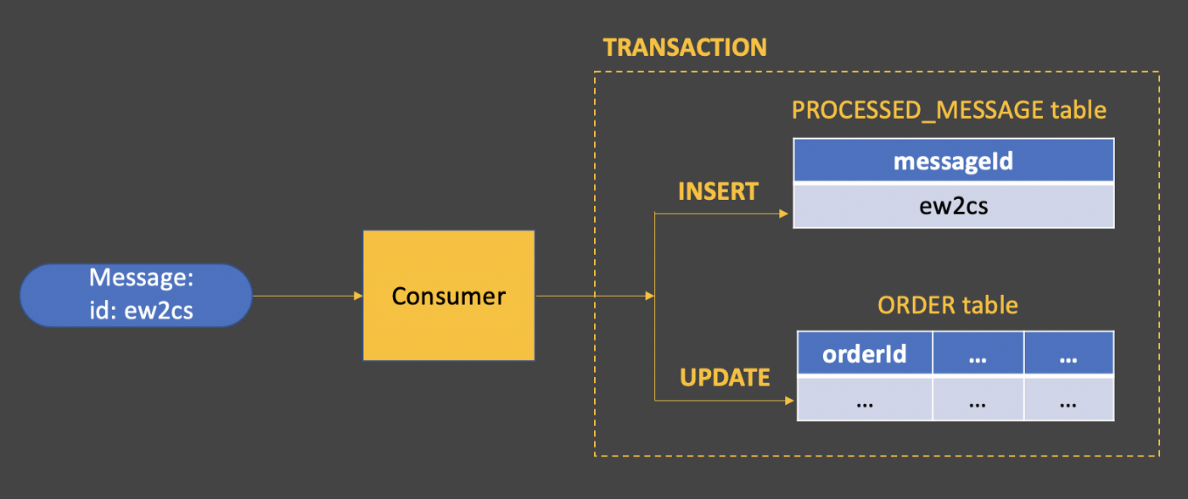

* Group :
* Kafka has grouping concept also
* If you have many consumers for one message and the consumers types are different
* You can assign one group for every type, so only these consumers which belongs to that type can read this message